What is the output of the following code:

byte destinationVar;
short sourceVar = 281;
destinationVar = (byte)sourceVar;
Console.WriteLine($"sourceVar val: {sourceVar}");
Console.WriteLine($"destinationVar val: {destinationVar}");
Sol: 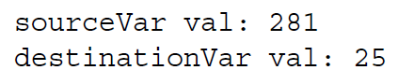
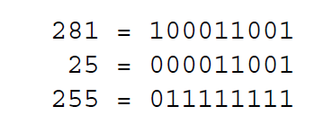
Two keywords exist for setting what is called the overflow checking context for an expression:
checked and unchecked.
byte destinationVar;
short sourceVar = 281;
destinationVar = checked((byte)sourceVar);
Console.WriteLine($"sourceVar val: {sourceVar}");
Console.WriteLine($"destinationVar val: {destinationVar}");

